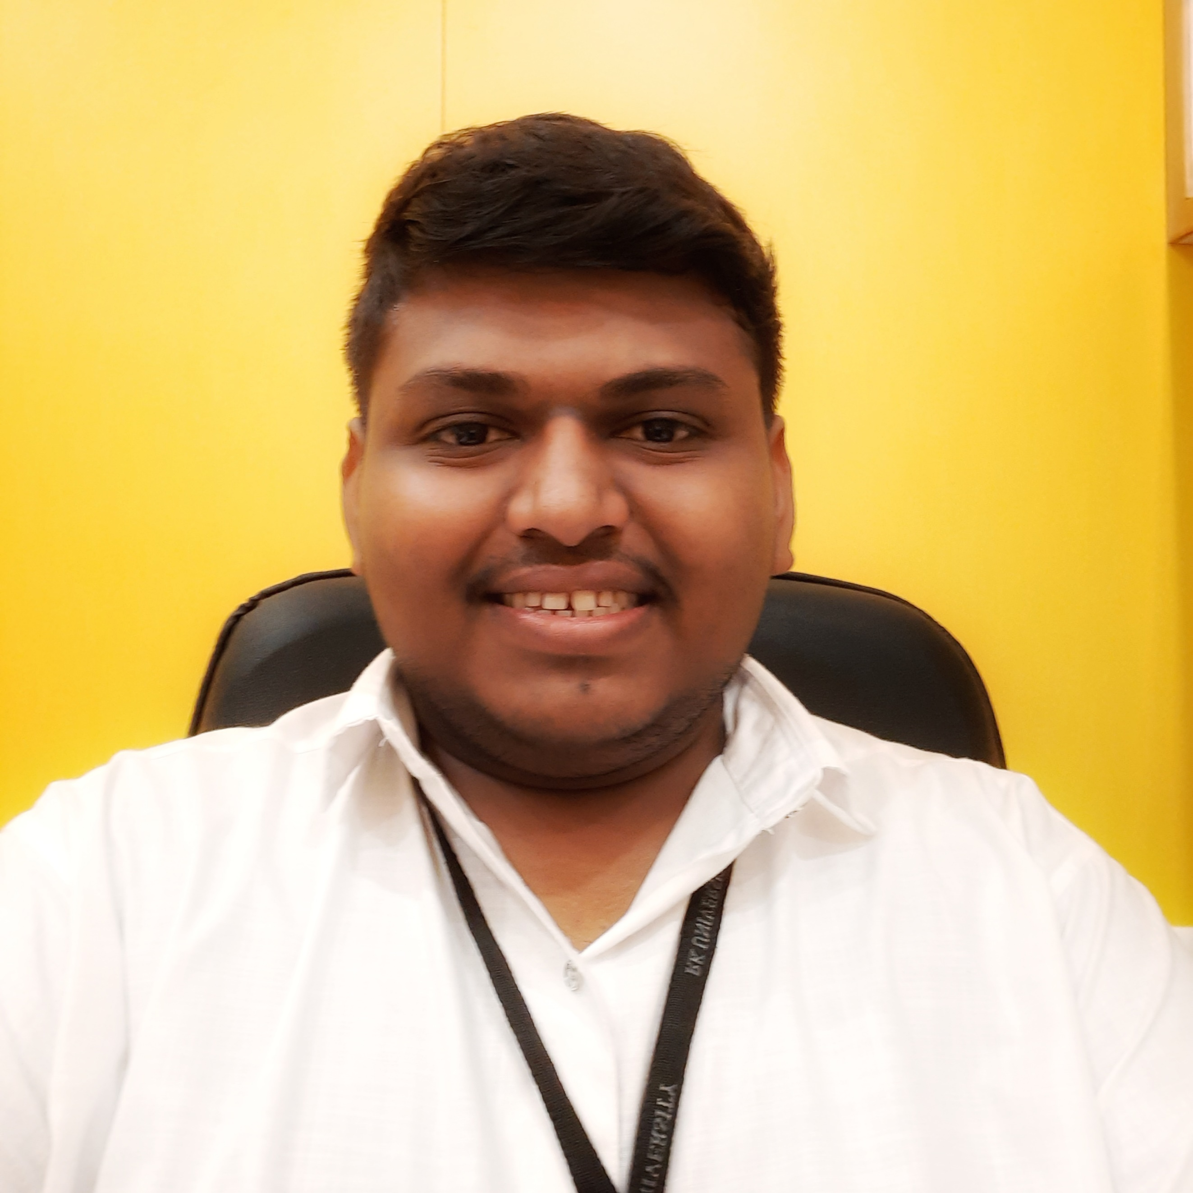

**Resume**

**Chetan Kochiyaniya**

**Cell : +91-635-307-4971**

**Email:** [**kochiyaniyachetan@gmail.com**](mailto:kochiyaniyachetan@gmail.com)

**Career Objective:**

I am having a wide range of technical knowledge for web development technologies and very adaptive towards trending tech stack. Looking for a company that can offer me challenging work and provides me an opportunity to explore new technologies for mutual growth.

**Educational Qualification:**

* Graduation **B. Tech (Computer Engineering)** Under RK University from School Of Engineering, Rajkot – (present)
* **H.S.C** under Gujarat Secondary and Higher Secondary Education Board, from Ultra Vision Academy, Surendranagar – 2019.
* **S.S.C** from Gujarat Secondary and Higher Secondary Education Board, Shree Adarsh Madhyamik Vidhyalaya, Botad – 2017.

**Technical Skills**

* React Js
* Python
* Web Development
* AR Creator
* C/C++
* Data structures and Algorithms

**Project:**

Topic: - Algo Craze | Algo Trading Portal

Duration**: -** 12-week project

Description: -

* <https://algocraze.com/>
* Algo Craze covers the full life cycle of Algorithmic Trading, including strategy development, backtesting, optimization and live trading

Topic: - Code4U

Duration**: -** 6-week project

Description: -

* <https://chetankochiyaniya.github.io/reactdemoapp/>

Create a demo service providing company website using react, mongo dB, express, node js.

Topic: - Vulnerabilities in An E-commerce Website

Duration**: -** 4-week project

Description: -

* <https://github.com/chetankochiyaniya/Vulnerabilities-in-an-e-commerce-website>
* Finding the vulnerabilities in E-commerce website and created a detailed developer report with possible solutions

**Achievements:**

* Winner in Arch-A-Thon
* Winner in IUCEE Student Summit – Idea Presentation
* Certified Ethical hacking Expert Level – 1.0
* Completed Ethical Hacking Training
* Participated In SaprkAR Hackathon
* Participated In F8 Refresh Hackathon
* Participated In E-Hackathon
* Participated In Smart City Rajkot Hackathon

**Personal Profile:**

|  |  |
| --- | --- |
| Name: | Chetan Kochiyaniya |
| Father Name: | Hakabhai |
| Date of Birth: | 03- October-2001 |
| Marital Status: | Unmarried |
| Nationality: | Indian |
| Languages Known: | English, Hindi and Gujarati |
| Address: | Sankardi, Botad, Gujarat, India, Pin code No :364720 |

**Declaration:**

I hereby declare that the above information is correct and true to the best of my knowledge and belief.

Place:

Date:

**Chetan Kochiyaniya**